# Quick Start

## Interface

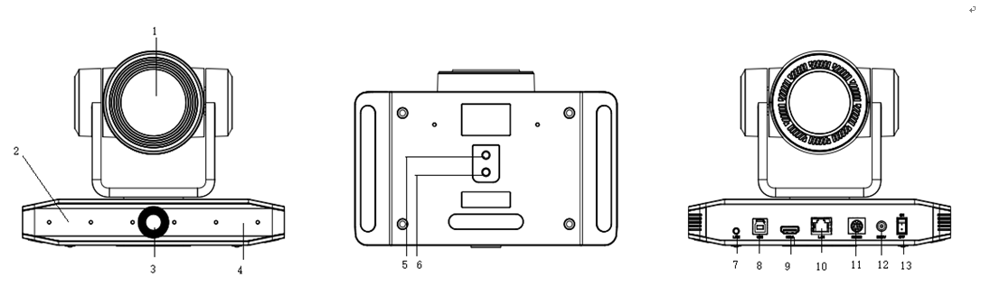

Interface

Interface

|  |  |  |
| --- | --- | --- |
| 1. Close-up Lens | 6. Fixation Hole | 11. RS232 Input |
| 2. Base | 7. Audio in | 12. DC12V Power Socket |
| 3. Panoramic Lens | 8. USB3.0 | 13. Power Switch |
| 4. Receiving Light | 9. HDMI Jack |  |
| 5. Tripod Screw Hole | 10. Network Jack |  |

**When using the camera, please put the plastic pad on the center bottom of device.**

## Power-on Self-Test

### Power on

Connect device to power socket with DC12V power adapter.

### Self-Test

After power on, the receiver light will start flashing and camera will do a brief pan-tilt tour and return to the home position. When light stop flashing, the self-test is finished.

* Default address of the remote control is 1#. When menu restore default setting, the address of IP remote control will restore 1#.
* If preset 0 is set, the camera will return to the preset 0 position after self-test

## Video Output

This series camera can output video through network, HDMI, and USB3.0.

### Network Output

a, Network connection: Shown as diagram 1.1 #10

b, Log in: You can reach the Web Interface by typing in the camera’s IP address(default 192.168.5.163) into a web browser. To log in, type in “admin” into the username and password fields. From the Web Interface, you can adjust many of your camera’s settings via this IP interface, like PTZ control, video recording, playback and configuration setting.

### HDMI Output

a, HDMI connection: Shown as diagram 1.1 #9

b, Connect camera to the display device via HDMI cable.

### USB3.0 Output

USB3.0 connection: Shown as diagram 1.1 #8. Open video software and select image device to output video.

## Bracket

* 
* Bracket can only be wall mounted or upside down mounted on template and concrete wall, but can not be installed on plasterboard.

### Steps of Wall Mount

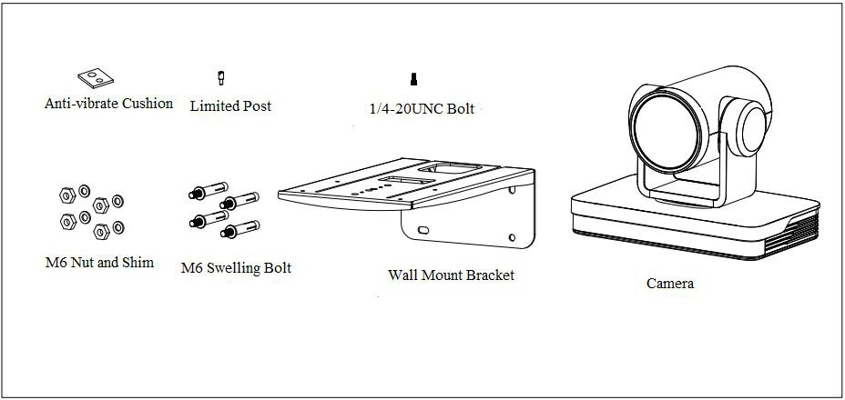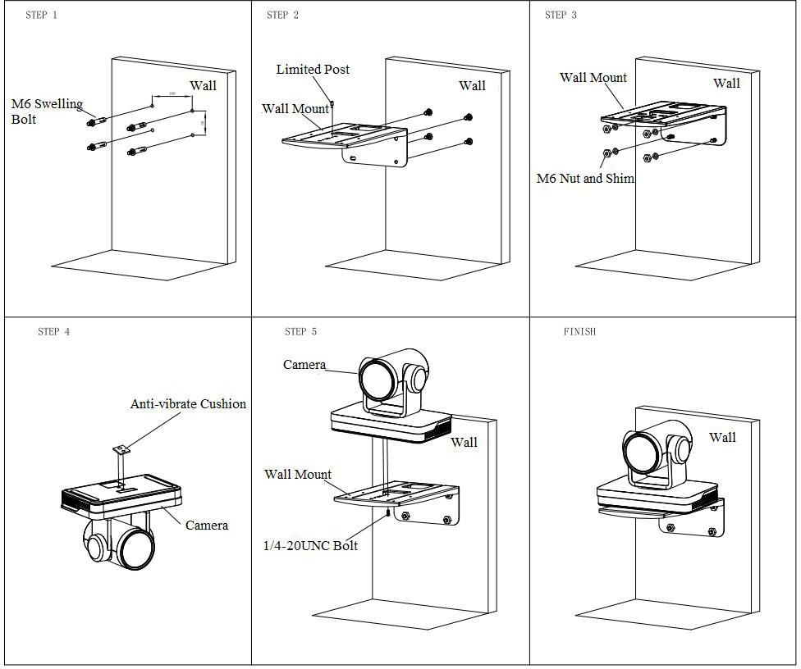

Steps of Wall Mount

### Steps of Ceiling Mount

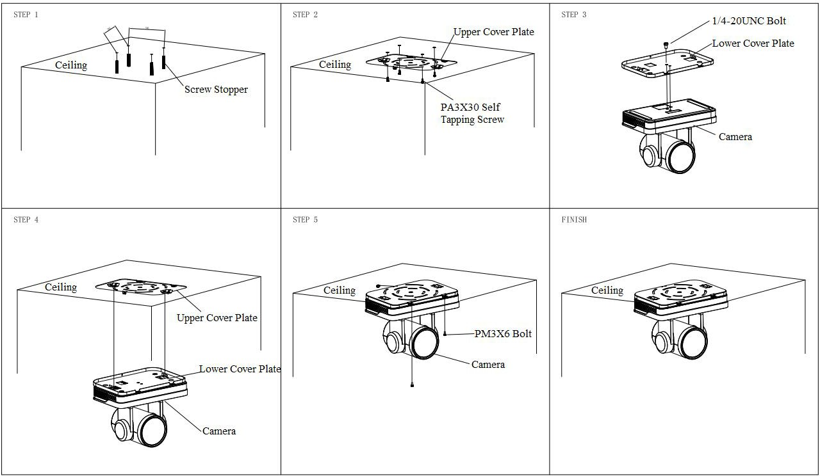

Steps of Ceiling Mount